2.1. 2017
Women Interest group Report | Chair: Darja Zavirsek  Co-chair: Fran Waugh | Zhang Lixi, Carolyne Noble, Helle Strauss, Nilsa Burgos , Ute Straub

Dear colleagues,

-We communicated with the organizers of the 2018 Dublin congress and provided the team of reviewers for the Women’s’ Stream; several members of the IASSW serve as reviwers of the abstracts; over 300 abstracts came to the Women’s Stream which is more than we expected; The topics announced for the call of the papers are: refugee women's issues; disabled women's issues; migrant women, care workers and the specific issues; work and family issues; feminist research and gender research; women’s history ; teaching gender and feminist social work; women and violence;sexuality and identity; women's reproductive rights; women in vulnerable contexts and social inequalities; Women and political conflicts ; local specific inequalities.
We applied with the Symposium to celebrate the 30th Anniversary of the Women Interest group of the IASSW, which we plan to be one of the major events celebrated together with the pioneers of social work leaders.

-Fran and Darja sent out the questionnaire a few more times before the Dublin conference in order to get a more comprehensive picture on what is going on in regard of women’s perspective in social work education.

-we also attach the power point of the UN Women Conference NGO; which included the work of the Women’s Interest Group.

Sincerely,
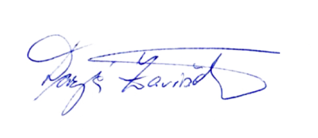

Darja Zaviršek, chair

